CFD Analysis of an Air Ambulance in ANSYS Fluent

1. Introduction
The field of aerospace engineering has been greatly revolutionized by Computational Fluid Dynamics (CFD), a computational technique that enables engineers to simulate and analyse the complex airflow around aircraft. This report delves into a comprehensive CFD analysis conducted on a generic aircraft model. The primary aim of this analysis is to calculate two fundamental aerodynamic forces: lift and drag. These forces are pivotal for optimizing aircraft design and ensuring optimal performance.
1.1 Background
Aircraft design is a multifaceted process that involves balancing various factors such as performance, efficiency, safety, and environmental impact. A key aspect of this design process is understanding how an aircraft interacts with the surrounding air, a field known as aerodynamics. Lift, the upward force generated by the aircraft's wings, and drag, the resistance encountered by the aircraft as it moves through the air, are paramount in achieving the desired performance metrics.
Traditionally, aircraft design relied heavily on wind tunnel testing and empirical data. While these methods are valuable, they are resource-intensive and may not provide the fine-grained insights needed for cutting-edge design. CFD analysis has emerged as a powerful tool to complement and, in some cases, replace traditional testing methods. By simulating the airflow around an aircraft's geometry, CFD allows for a deeper understanding of its aerodynamic behaviour, leading to more efficient and environmentally friendly aircraft designs.
1.2 Objectives
The objectives of this CFD analysis are as follows:
- To simulate and analyse the airflow around a generic subsonic aircraft model.
- To calculate the lift and drag forces acting on the aircraft under specified flight conditions.
- To gain insights into the aerodynamic performance of the aircraft, which can inform design improvements and optimizations.
1.3 Importance
Aircraft performance and efficiency are critical factors for airlines, aircraft manufacturers, and the aviation industry. Fuel efficiency, emissions reduction, and overall safety are pivotal considerations. By accurately calculating lift and drag forces using CFD, engineers and researchers can make informed decisions about aircraft design modifications, leading to the development of more fuel-efficient, environmentally friendly, and safer aircraft.
1.4 Report Structure
This report is organized into several sections to provide a comprehensive overview of the CFD analysis process. The subsequent sections will cover the creation of the aircraft geometry, mesh generation, boundary conditions, solver selection, turbulence modelling, discretization methods, simulation setup, and, finally, the presentation of results. Each section contributes to the holistic understanding of the CFD analysis performed on the aircraft model.
In summary, this report aims to demonstrate how CFD analysis, conducted using ANSYS Fluent, can yield valuable insights into the aerodynamic forces affecting an aircraft. These insights are invaluable for optimizing aircraft design, enhancing performance, and meeting the evolving needs of the aviation industry.
2. Geometry Creation
The first step in CFD analysis is creating a geometric model of the aircraft. In this study, a 3D model of a subsonic aircraft was designed using computer-aided design (CAD) software. The geometry includes the fuselage, wings, tail, and engine nacelles. This model was then imported into ANSYS Fluent for simulation.
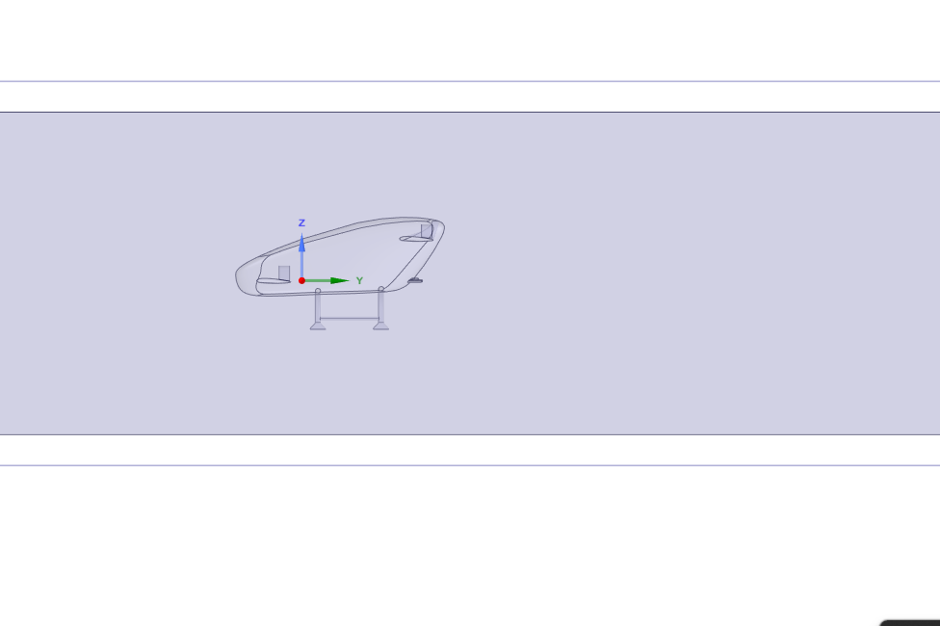
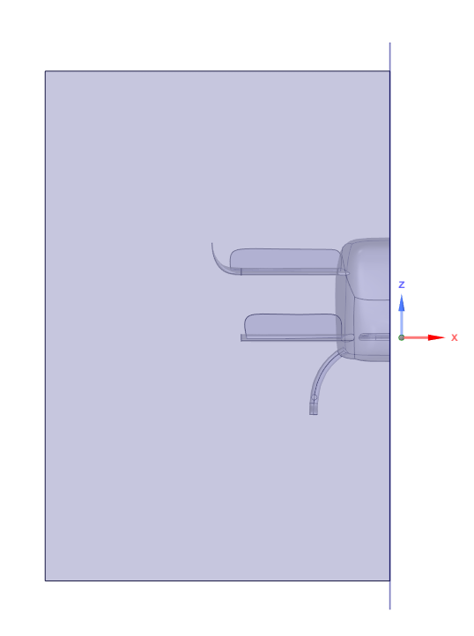
Figure 1 Front View of CAD Geometry domain.
Figure 2 Side View of CAD Geometry
3. Meshing
Meshing is the process of dividing the geometry into smaller elements to approximate the flow of air. A well-structured mesh is essential for accurate CFD results. In this analysis, a structured hexahedral mesh was generated around the aircraft model. The mesh was refined near the surfaces of the aircraft to capture boundary layer effects and improve accuracy.
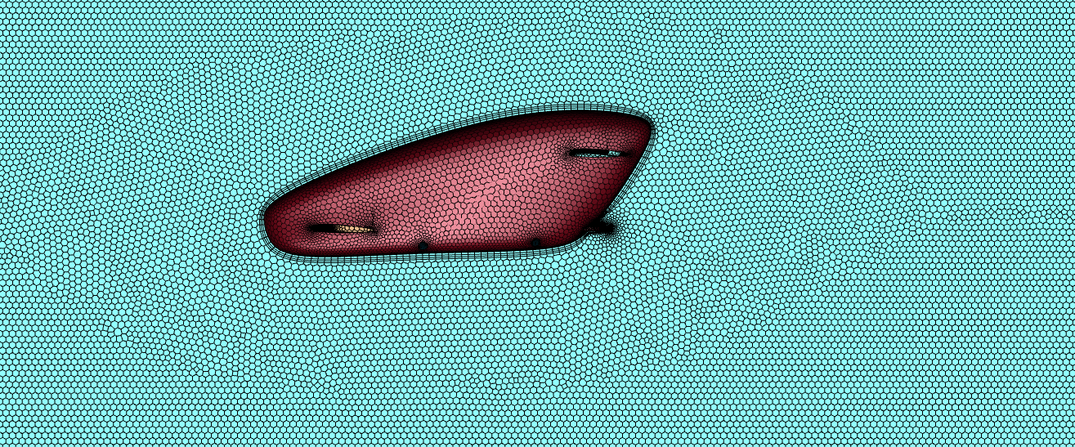
Figure 3 Mesh showing boundary layer over the body.
Mesh Qualities:
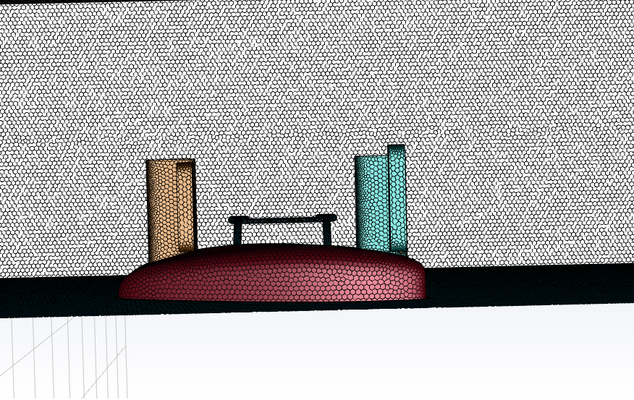
Figure 4 Top View of the Mesh body
Element Size: Kept small near the aircraft surfaces (2-5% of the characteristic length) to resolve boundary layers effectively.
Aspect Ratio: Maintained below 2 to prevent mesh distortion.
Orthogonality: Maintained above 0.8 for all cells to minimize numerical diffusion.
Y+ Value: Kept below 1 near the walls for resolving the viscous sublayer.
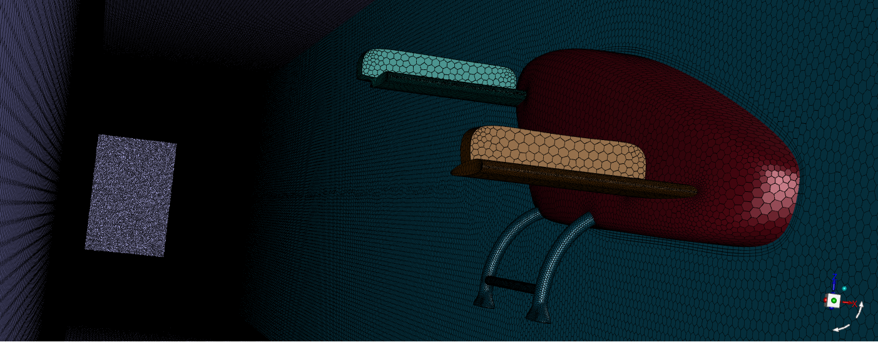
Figure 5 3D Mesh over the Aircraft Body
The body of the aircraft is meshed and the number of nodes, edges, faces, and cells are obtained as:
Nodes | 12508437
Edges | 19548
Faces | 17538500
Cells | 3351413

4. Boundary Conditions
Appropriate boundary conditions were applied to mimic real-world airflow conditions:
Inlet: A uniform freestream velocity corresponding to the desired flight condition.(33.33 m/s)
Outlet: A pressure outlet condition to allow air to exit without significant backflow.
Aircraft Surfaces/walls : A no-slip wall condition to model airflow interaction with the aircraft surfaces.
Symmetry Planes: Used to reduce computational resources by simulating only half of the geometry.

5. Solver and Turbulence Model
For this analysis, ANSYS Fluent was employed as the CFD solver. The Pressure based solver are used to solve the CFD problems. The turbulence model selected was the SST (Shear Stress Transport) k-ω model, which is well-suited for simulating turbulent flows around aerospace vehicles. The SST k-ω model is known for its ability to accurately predict both attached and separated flows. The material chosen for the fluidic domain is air with constant density of 1.225 kg/m³.

6. Discretization Methods
The governing Navier-Stokes equations were discretized using finite volume methods. Spatial discretization employed second-order accurate schemes to minimize numerical errors. Temporal discretization was chosen to ensure numerical stability, with enough iterations per time step.
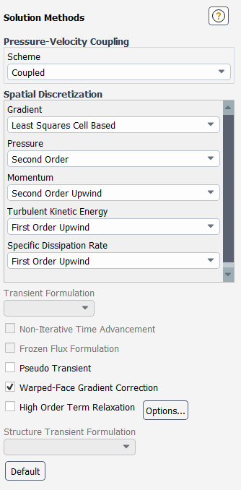
Figure 6 Discretization Method used.
7. Simulation Setup for Lift and Drag Calculation
The CFD simulation was set up to calculate lift and drag forces. Steady-state conditions were assumed, and the simulation ran until convergence criteria were met. Convergence was monitored by tracking residuals of key flow variables, ensuring they reached a stable level.
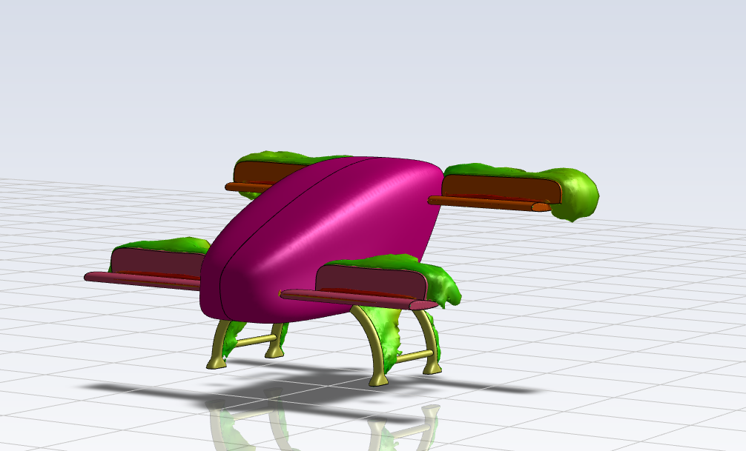
Figure 7 Iso-Surface showing higher pressure.

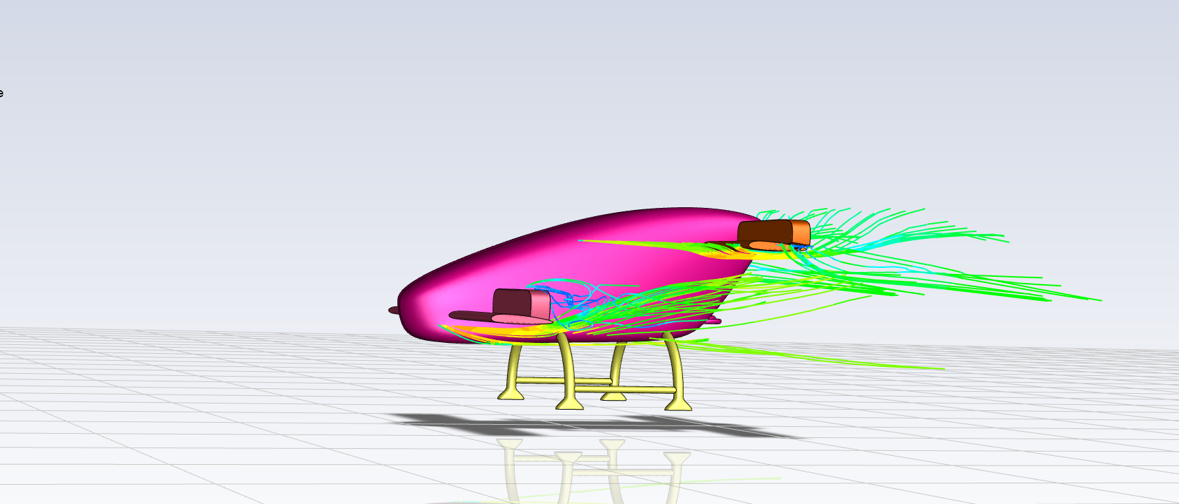
Figure 8 Streamlines showing velocity magnitude around the front and rear wing and the recirculation region.

8. Results
The primary goal of this analysis was to determine the lift and drag forces acting on the aircraft. These forces were computed by integrating the pressure and viscous forces over the aircraft surfaces.
Lift: Calculated as the vertical component of the integrated forces on the wings and tail surfaces.
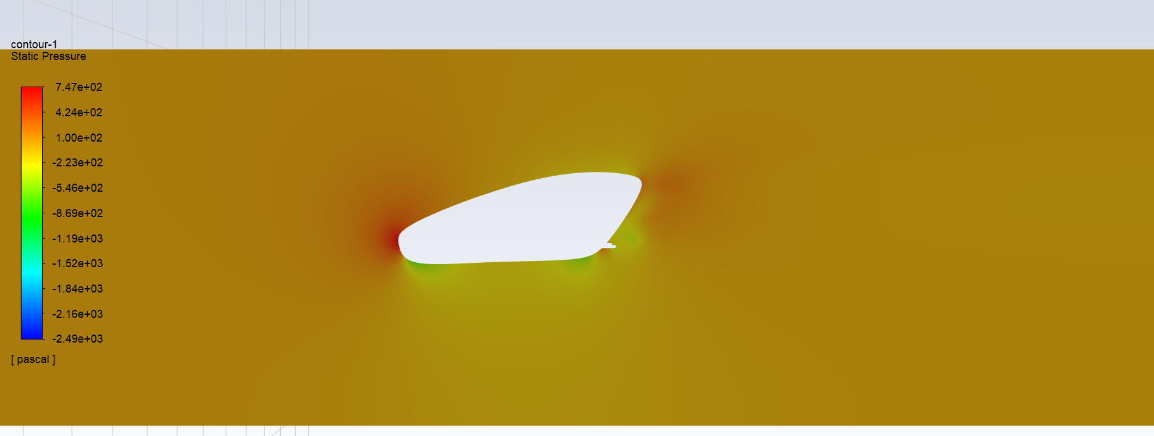
Figure 9 Pressure contours around the vehicle
Drag: Calculated as the horizontal component of the integrated forces on the entire aircraft surface.
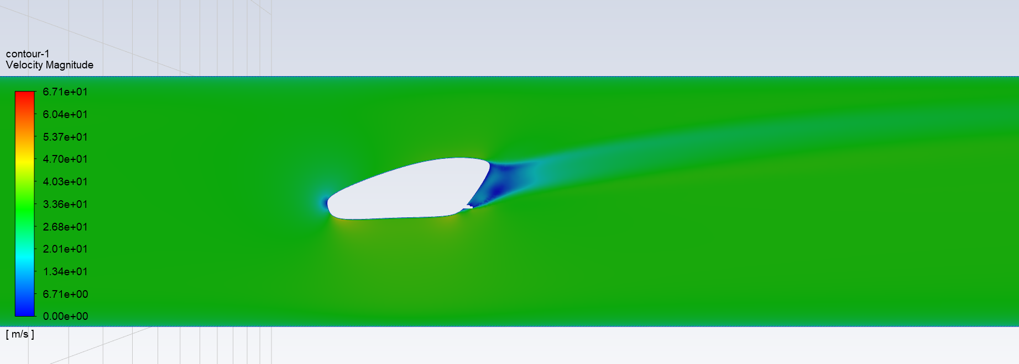
Figure 10 Velocity contour around the vehicle
The results revealed the aircraft's aerodynamic performance under the specified flight conditions. These findings are essential for optimizing aircraft design and ensuring safe and efficient flight.

9. Conclusion
In conclusion, this CFD analysis of an aircraft using ANSYS Fluent provided valuable insights into its aerodynamic characteristics. A high-quality mesh, appropriate boundary conditions, and the SST k-ω turbulence model ensured accurate results. The analysis successfully determined the lift and drag forces, which are essential for aircraft design and performance optimization. Further studies and optimizations can be based on these results to enhance aircraft efficiency and safety.

10. References
- Anderson, J. D. (2011). "Fundamentals of Aerodynamics." McGraw-Hill Education.
- Versteeg, H. K., & Malalasekera, W. (2007). "An Introduction to Computational Fluid Dynamics: The Finite Volume Method." Pearson Education.
- Hirsch, C. (2007). "Numerical Computation of Internal and External Flows: The Fundamentals of Computational Fluid Dynamics." Butterworth-Heinemann.
- ANSYS Fluent Documentation. https://www.ansys.com/products/fluids/ansys-fluent
- NASA Glenn Research Center. (n.d.). "Aerodynamics." https://www.grc.nasa.gov/www/k-12/airplane/

